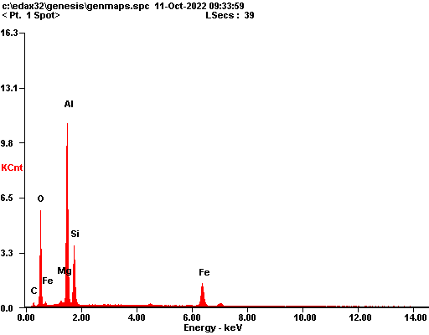

|  |  |  |
| --- | --- | --- |
| ***Element*** | ***Wt%*** | ***At%*** |
| ***CK*** | 06.41 | 10.98 |
| ***OK*** | 40.22 | 51.74 |
| ***MgK*** | 00.80 | 00.68 |
| ***AlK*** | 30.38 | 23.18 |
| ***SiK*** | 14.38 | 10.54 |
| ***FeK*** | 07.81 | 02.88 |
| ***Matrix*** | Correction | ZAF |

